Test Documentation

Manual Testing – API Consumer

|  |  |
| --- | --- |
| User Story | General – Applies to All |
| Test Case ID | 1 |
| Description | Using an invalid URL |
| Given | 1. The Application Server and Database Server is running 2. Postman REST Client Opened |
| When | 1. Set GET request 2. Enter URL <http://localhost:80/TekkenApp/fighters/> 3. Press send |
| Then | 1. HTTP Response 404 Not Found |
| Test Status | Passed |

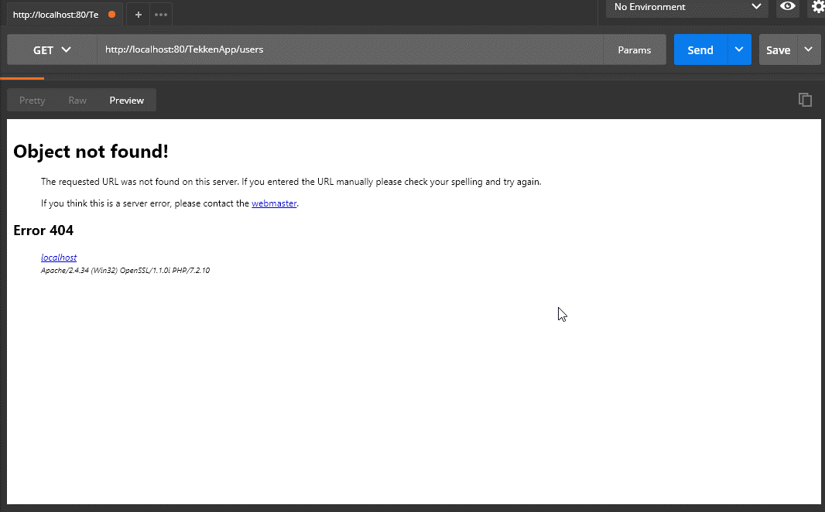

|  |  |
| --- | --- |
| User Story | General – Applies to all |
| Test Case ID | 2 |
| Description | Database is unavailable |
| Given | 1. The Application Server is running 2. The Database Server is stopped 3. Postman REST Client Opened |
| When | 1. Set GET request 2. Enter URL <http://localhost:80/TekkenApp/api/fighters/> 3. Press send |
| Then | 1. HTTP Response 500 Internal Server Error |
| Test Status | Passed |

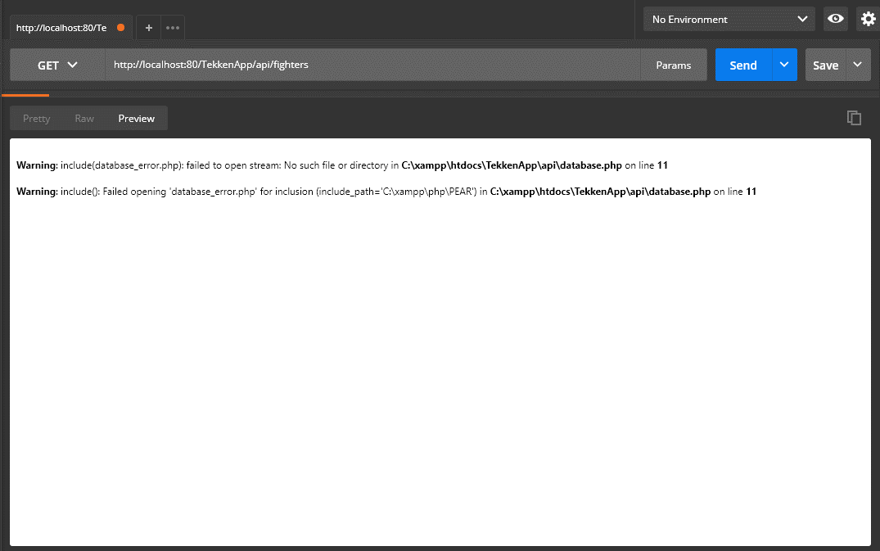

|  |  |
| --- | --- |
| User Story 1 | As an API Consumer, I want to retrieve data in JSON format for all fighters, so that I can use the data in my client application. |
| Test Case ID | 3 |
| Description | Retrieve data for all fighters – Success |
| Given | 1. The Application Server and Database Server is running 2. Postman REST Client Opened |
| When | 1. Set GET request 2. Enter URL <http://localhost:80/TekkenApp/api/fighters/> 3. Press send |
| Then | 1. HTTP Response 200 OK 2. All database entries are displayed in JSON format |
| Test Status | Passed |

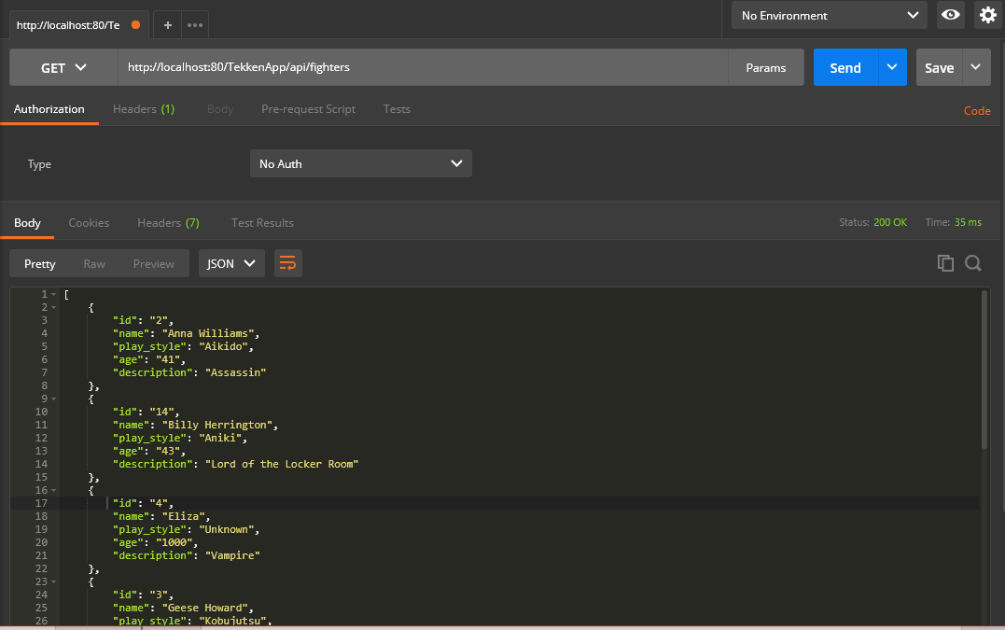

|  |  |
| --- | --- |
| User Story 2 | As an API Consumer, I want to retrieve data in JSON format for one fighter based on its ID, so that I can use the data in my client application. |
| Test Case ID | 4 |
| Description | Retrieve data based on ID - Success |
| Given | 1. The Application Server and Database Server is running 2. Postman REST Client Opened |
| When | 1. Set GET request 2. Enter URL [http://localhost:80/TekkenApp/api/fighters/{valid id}](http://localhost:80/TekkenApp/api/fighters/%7bvalid%20id%7d) 3. Press send |
| Then | 1. HTTP Response 200 OK 2. Details for fighters displayed corresponding to entered ID |
| Test Status | Passed |

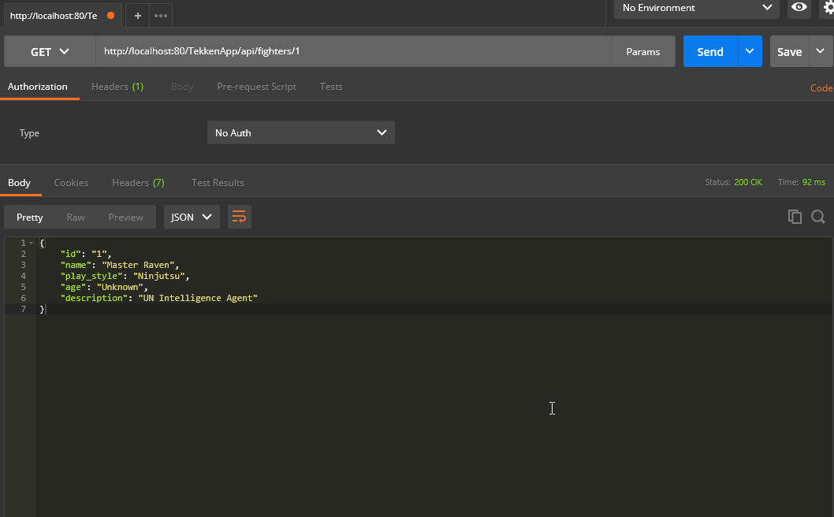

|  |  |
| --- | --- |
| User Story 2 | As an API Consumer, I want to retrieve data in JSON format for one fighter based on its ID, so that I can use the data in my client application. |
| Test Case ID | 5 |
| Description | Input invalid ID - Success |
| Given | 1. The Application Server and Database Server is running 2. Postman REST Client Opened |
| When | 1. Set GET request 2. Enter URL [http://localhost:80/TekkenApp/api/fighters/{invalid id}](http://localhost:80/TekkenApp/api/fighters/%7binvalid%20id%7d) 3. Press send |
| Then | 1. HTTP Response 200 OK 2. Empty JSON data |
| Test Status | Passed |

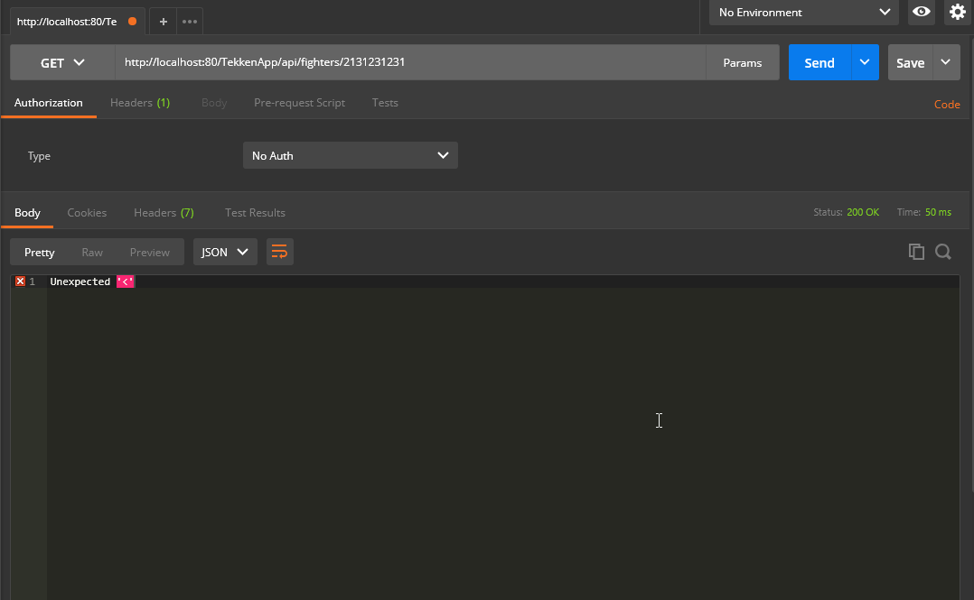

|  |  |
| --- | --- |
| User Story 3 | As an API Consumer, I want to retrieve a list of fighters in JSON format for a specified name, so that I can use the data in my client application. |
| Test Case ID | 6 |
| Description | Retrieve data based on name – Success |
| Given | 1. The Application Server and Database Server is running 2. Postman REST Client Opened |
| When | 1. Set GET request 2. Enter URL  [http://localhost:80/TekkenApp/api/fighters/search/{valid_name}](http://localhost:80/TekkenApp/api/fighters/search/%7bvalid_name%7d) 3. Press send |
| Then | 1. HTTP Response 200 2. List of correct fighters displayed |
| Test Status | Passed |

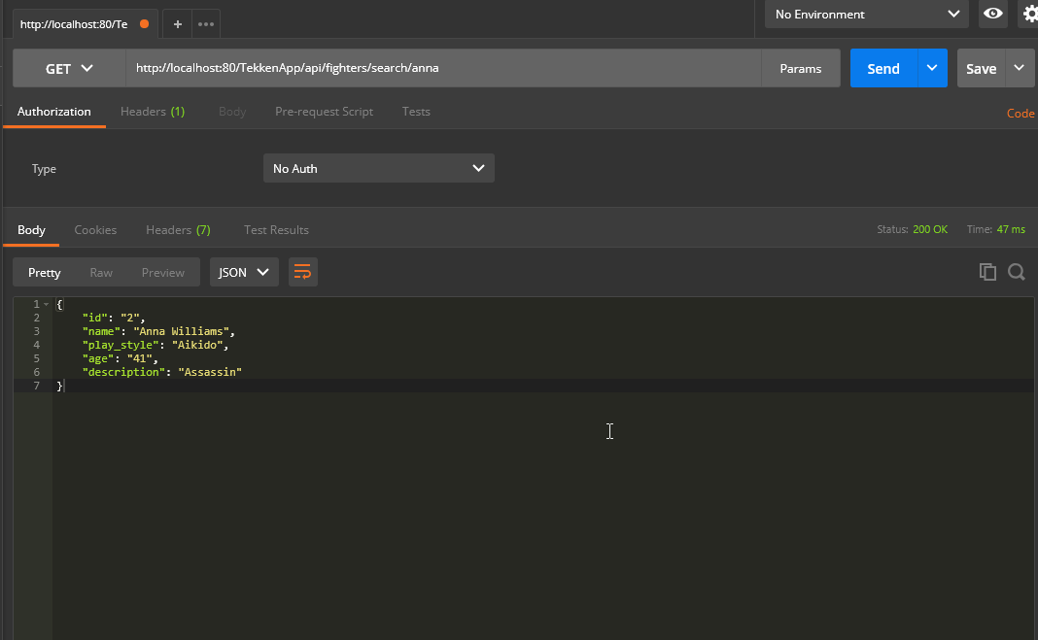

|  |  |
| --- | --- |
| User Story 3 | As an API Consumer, I want to retrieve a list of fighters in JSON format for a specified name, so that I can use the data in my client application. |
| Test Case ID | 7 |
| Description | Incorrect name is entered when retrieving a fighter - Success |
| Given | 1. The Application Server and Database Server is running 2. Postman REST Client Opened |
| When | 1. Set GET request 2. Enter URL  [http://localhost:80/TekkenApp/api/fighters/search/{invalid_name}](http://localhost:80/TekkenApp/api/fighters/search/%7binvalid_name%7d) 3. Press send |
| Then | 1. HTTP Response 200 2. Empty JSON data |
| Test Status | Passed |

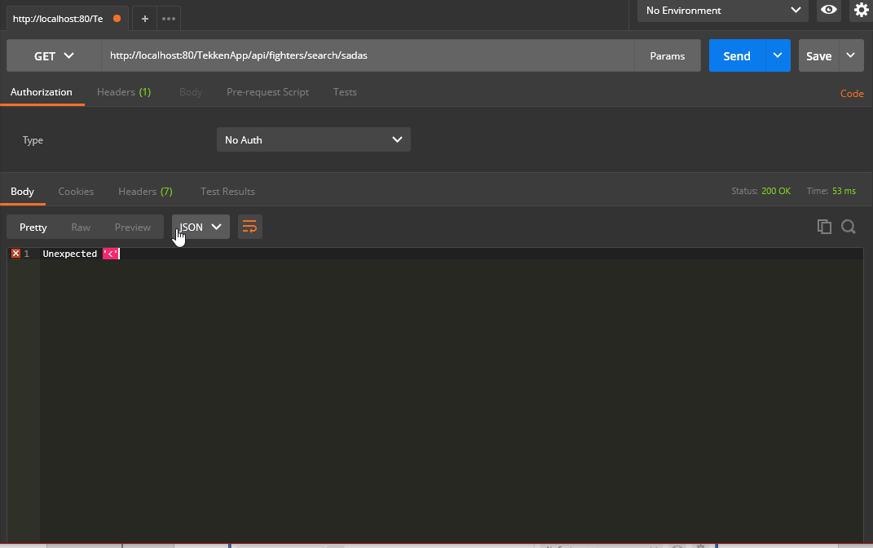

|  |  |
| --- | --- |
| User Story 4 | As an API Consumer, I want to add a new fighter through JSON, so that I can use the data in my client application. |
| Test Case ID | 8 |
| Description | Adding a new fighter to the database– Success |
| Given | 1. The Application Server and Database Server is running 2. Postman REST Client Opened |
| When | 1. Set GET request 2. Enter URL  [http://localhost:80/TekkenApp/api/fighters/](http://localhost:80/TekkenApp/api/fighters/search/%7binvalid_name%7d) 3. Press send |
| Then | 1. HTTP Response 200 2. JSON data added to the fighter database |
| Test Status | Passed |

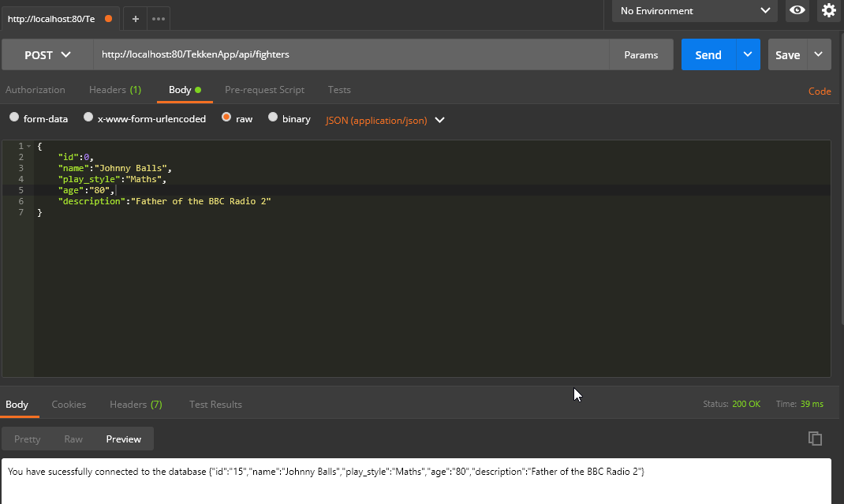

|  |  |
| --- | --- |
| User Story 4 | As an API Consumer, I want to add a new fighter through JSON, so that I can use the data in my client application. |
| Test Case ID | 9 |
| Description | Incorrect parameters when adding a new fighter – Success |
| Given | 1. The Application Server and Database Server is running 2. Postman REST Client Opened |
| When | 1. Set GET request 2. Enter URL  [http://localhost:80/TekkenApp/api/fighters/](http://localhost:80/TekkenApp/api/fighters/search/%7binvalid_name%7d) 3. Press send |
| Then | 1. Slim Error |
| Test Status | Passed |

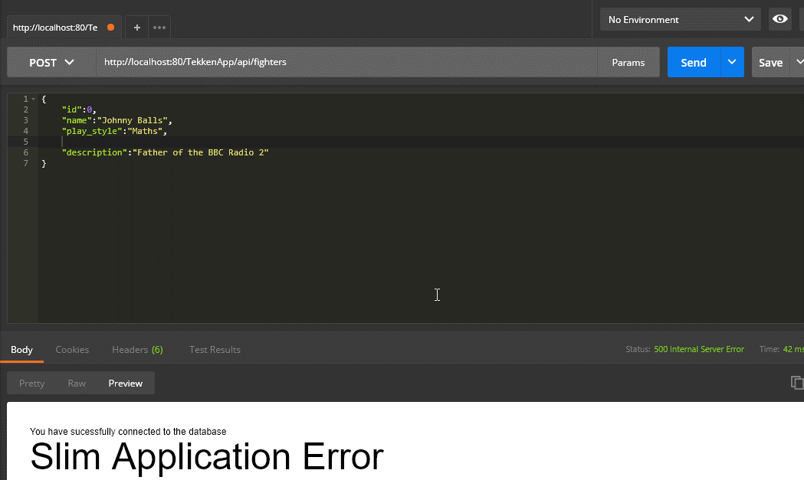

|  |  |
| --- | --- |
| User Story 5 | As an API Consumer, I want to update a fighter through JSON, so that I can use the data in my client application. |
| Test Case ID | 10 |
| Description | The details of the fighter were updated – Success |
| Given | 1. The Application Server and Database Server is running 2. Postman REST Client Opened |
| When | 1. Set GET request 2. Enter URL  [http://localhost:80/TekkenApp/api/fighters/](http://localhost:80/TekkenApp/api/fighters/search/%7binvalid_name%7d){valid id} 3. Press send |
| Then | 1. HTTP Response 200 2. Database updated |
| Test Status | Passed |

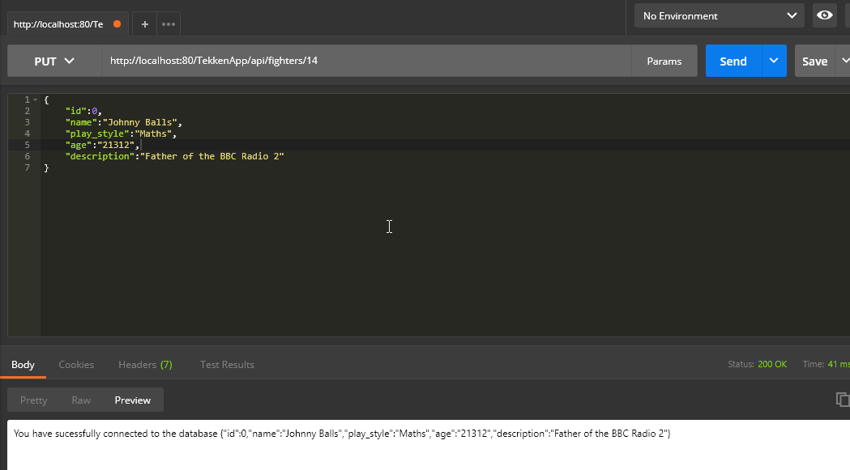

|  |  |
| --- | --- |
| User Story 5 | As an API Consumer, I want to update a fighter through JSON, so that I can use the data in my client application. |
| Test Case ID | 11 |
| Description | Incorrect parameters entered – Success |
| Given | 1. The Application Server and Database Server is running 2. Postman REST Client Opened |
| When | 1. Set GET request 2. Enter URL  [http://localhost:80/TekkenApp/api/fighters/](http://localhost:80/TekkenApp/api/fighters/search/%7binvalid_name%7d){invalid id} 3. Press send |
| Then | 1. Slim Application Error |
| Test Status | Passed |

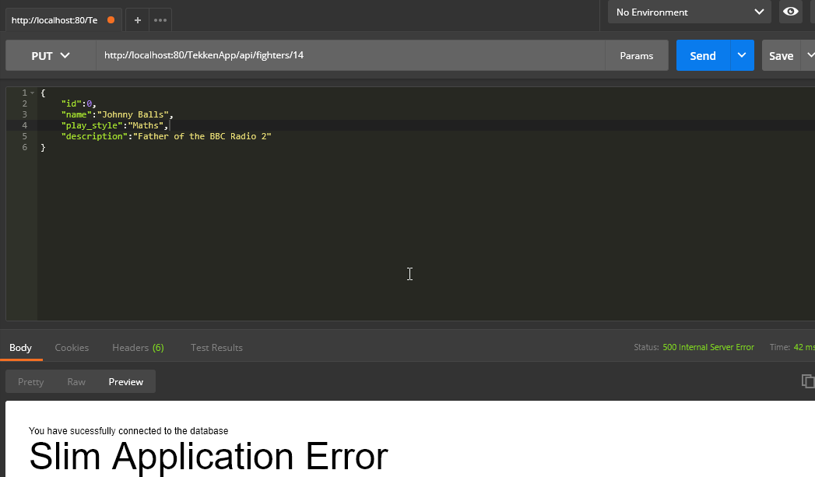

|  |  |
| --- | --- |
| User Story 6 | As an API Consumer, I want to delete a fighter through JSON, so that I can use the data in my client application. |
| Test Case ID | 12 |
| Description | The fighter was deleted – Success |
| Given | 1. The Application Server and Database Server is running 2. Postman REST Client Opened |
| When | 1. Set GET request 2. Enter URL  [http://localhost:80/TekkenApp/api/fighters/](http://localhost:80/TekkenApp/api/fighters/search/%7binvalid_name%7d){valid id} 3. Press send |
| Then | 1. HTTP Response 200 2. Row deleted from table |
| Test Status | Passed |

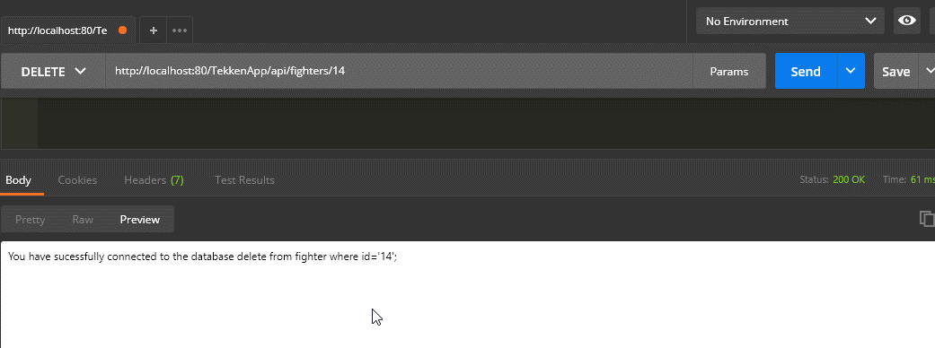

|  |  |
| --- | --- |
| User Story 6 | As an API Consumer, I want to delete a fighter through JSON, so that I can use the data in my client application. |
| Test Case ID | 13 |
| Description | Invalid ID entered – Success |
| Given | 1. The Application Server and Database Server is running 2. Postman REST Client Opened |
| When | 1. Set GET request 2. Enter URL  [http://localhost:80/TekkenApp/api/fighters/](http://localhost:80/TekkenApp/api/fighters/search/%7binvalid_name%7d){invalid id} 3. Press send |
| Then | 1. HTTP Response 200 2. Row not deleted from table |
| Test Status | Passed |

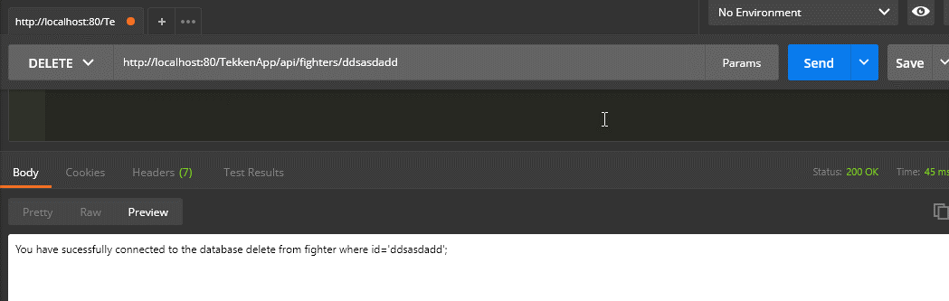

|  |  |
| --- | --- |
| User Story | General – Applies to All |
| Test Case ID | 1 |
| Description | Using an invalid URL |
| Given | 1. The Application Server and Database Server is running 2. Postman REST Client Opened |
| When | 1. Set GET request 2. Enter URL <http://localhost:80/TekkenApp/users/> 3. Press send |
| Then | 1. HTTP Response 404 Not Found |
| Test Status | Passed |



|  |  |
| --- | --- |
| User Story | General – Applies to all |
| Test Case ID | 2 |
| Description | Database is unavailable |
| Given | 1. The Application Server is running 2. The Database Server is stopped 3. Postman REST Client Opened |
| When | 1. Set GET request 2. Enter URL <http://localhost:80/TekkenApp/api/users/> 3. Press send |
| Then | 1. HTTP Response 500 Internal Server Error |
| Test Status | Passed |



|  |  |
| --- | --- |
| User Story 1 | As an API Consumer, I want to retrieve data in JSON format for all users, so that I can use the data in my client application. |
| Test Case ID | 3 |
| Description | Retrieve data for all fighters – Success |
| Given | 1. The Application Server and Database Server is running 2. Postman REST Client Opened |
| When | 1. Set GET request 2. Enter URL <http://localhost:80/TekkenApp/api/users/> 3. Press send |
| Then | 1. HTTP Response 200 OK 2. All database entries are displayed in JSON format |
| Test Status | Passed |

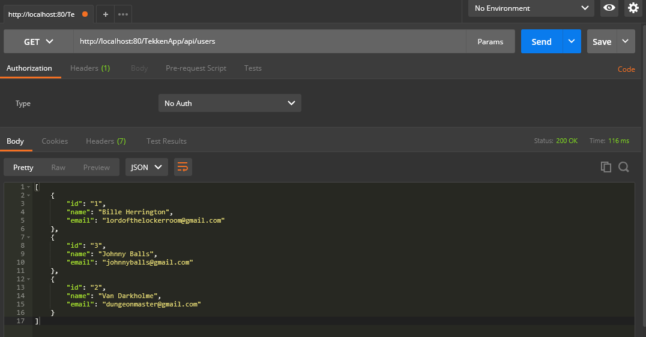

|  |  |
| --- | --- |
| User Story 2 | As an API Consumer, I want to retrieve data in JSON format for one user based on its ID, so that I can use the data in my client application. |
| Test Case ID | 4 |
| Description | Retrieve data based on ID - Success |
| Given | 1. The Application Server and Database Server is running 2. Postman REST Client Opened |
| When | 1. Set GET request 2. Enter URL [http://localhost:80/TekkenApp/api/users/{valid id}](http://localhost:80/TekkenApp/api/users/%7bvalid%20id%7d) 3. Press send |
| Then | 1. HTTP Response 200 OK 2. Details for fighters displayed corresponding to entered ID |
| Test Status | Passed |

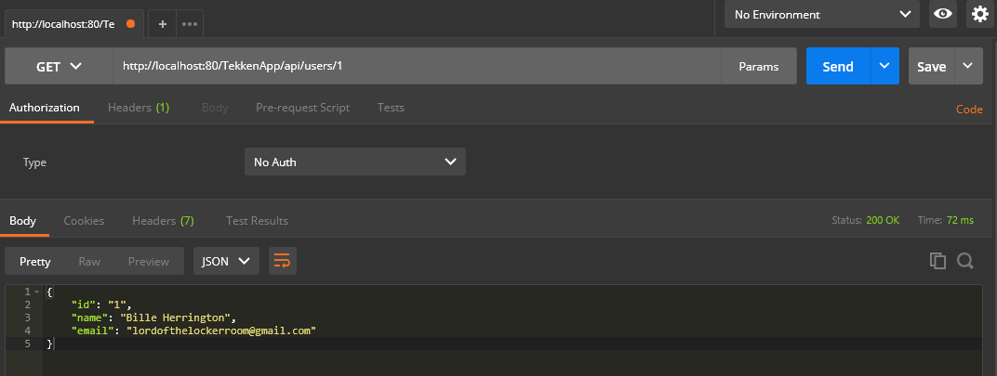

|  |  |
| --- | --- |
| User Story 2 | As an API Consumer, I want to retrieve data in JSON format for one user based on its ID, so that I can use the data in my client application. |
| Test Case ID | 5 |
| Description | Input invalid ID - Success |
| Given | 1. The Application Server and Database Server is running 2. Postman REST Client Opened |
| When | 1. Set GET request 2. Enter URL [http://localhost:80/TekkenApp/api/users/{invalid id}](http://localhost:80/TekkenApp/api/users/%7binvalid%20id%7d) 3. Press send |
| Then | 1. HTTP Response 200 OK 2. Empty JSON data |
| Test Status | Passed |

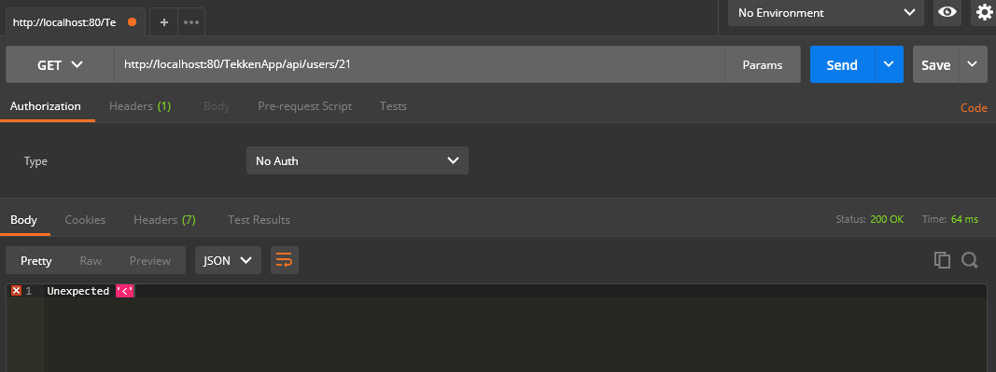

|  |  |
| --- | --- |
| User Story 3 | As an API Consumer, I want to retrieve a list of users in JSON format for a specified name, so that I can use the data in my client application. |
| Test Case ID | 6 |
| Description | Retrieve data based on name – Success |
| Given | 1. The Application Server and Database Server is running 2. Postman REST Client Opened |
| When | 1. Set GET request 2. Enter URL  [http://localhost:80/TekkenApp/api/users/search/{valid_name}](http://localhost:80/TekkenApp/api/users/search/%7bvalid_name%7d) 3. Press send |
| Then | 1. HTTP Response 200 2. List of correct fighters displayed |
| Test Status | Passed |

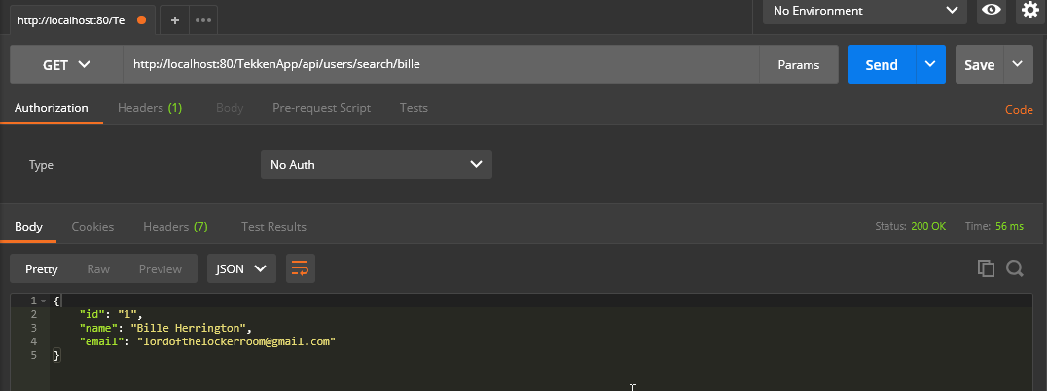

|  |  |
| --- | --- |
| User Story 3 | As an API Consumer, I want to retrieve a list of users in JSON format for a specified name, so that I can use the data in my client application. |
| Test Case ID | 7 |
| Description | Incorrect name is entered when retrieving a user - Success |
| Given | 1. The Application Server and Database Server is running 2. Postman REST Client Opened |
| When | 1. Set GET request 2. Enter URL  [http://localhost:80/TekkenApp/api/users/search/{invalid_name}](http://localhost:80/TekkenApp/api/users/search/%7binvalid_name%7d) 3. Press send |
| Then | 1. HTTP Response 200 2. Empty JSON data |
| Test Status | Passed |

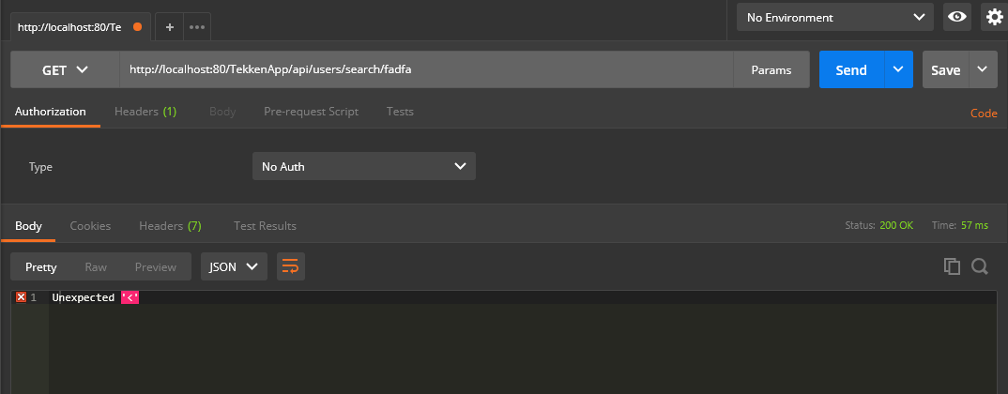

|  |  |
| --- | --- |
| User Story 4 | As an API Consumer, I want to add a new user through JSON, so that I can use the data in my client application. |
| Test Case ID | 8 |
| Description | Adding a new user to the database– Success |
| Given | 1. The Application Server and Database Server is running 2. Postman REST Client Opened |
| When | 1. Set GET request 2. Enter URL  <http://localhost:80/TekkenApp/api/users/> 3. Press send |
| Then | 1. HTTP Response 200 2. JSON data added to the fighter database |
| Test Status | Passed |

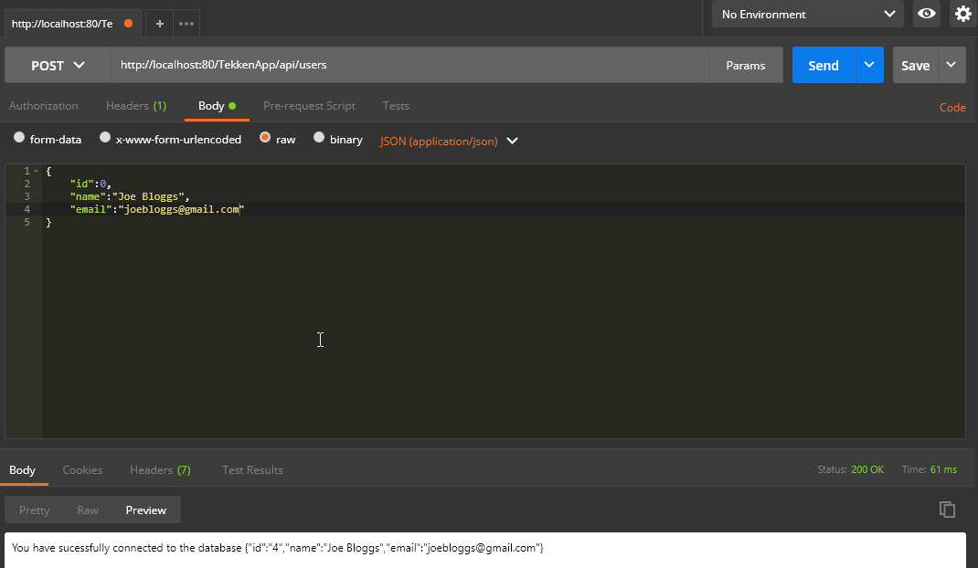

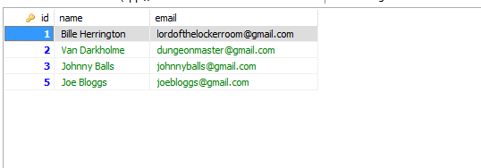

|  |  |
| --- | --- |
| User Story 4 | As an API Consumer, I want to add a new user through JSON, so that I can use the data in my client application. |
| Test Case ID | 9 |
| Description | Incorrect parameters when adding a new user – Success |
| Given | 1. The Application Server and Database Server is running 2. Postman REST Client Opened |
| When | 1. Set GET request 2. Enter URL  <http://localhost:80/TekkenApp/api/users/> 3. Press send |
| Then | 1. Slim Error |
| Test Status | Passed |

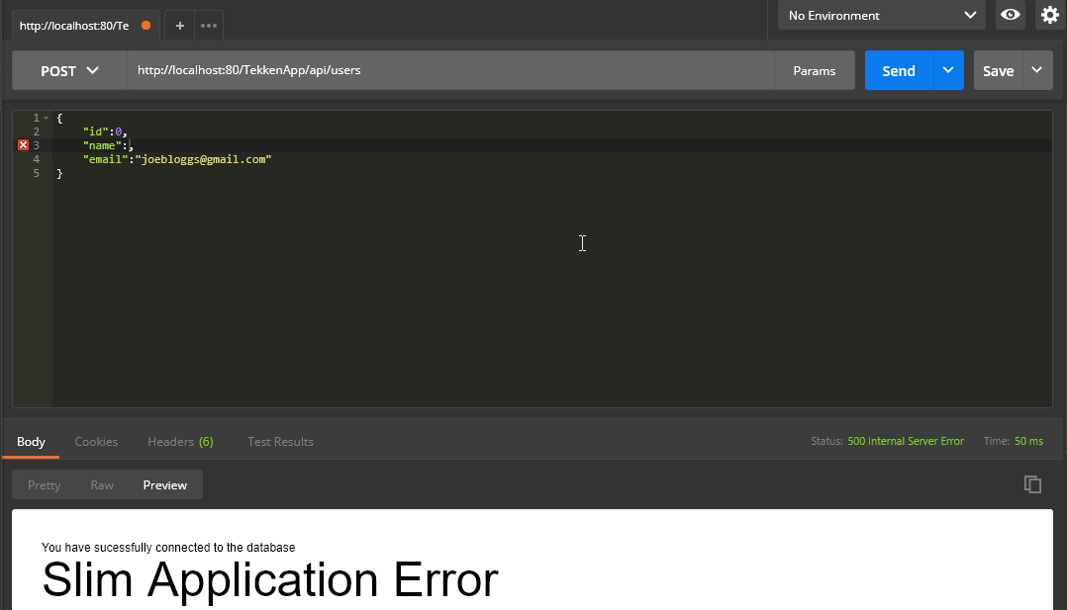

|  |  |
| --- | --- |
| User Story 5 | As an API Consumer, I want to update a user through JSON, so that I can use the data in my client application. |
| Test Case ID | 10 |
| Description | The details of the user were updated – Success |
| Given | 1. The Application Server and Database Server is running 2. Postman REST Client Opened |
| When | 1. Set GET request 2. Enter URL  <http://localhost:80/TekkenApp/api/users/>{valid id} 3. Press send |
| Then | 1. HTTP Response 200 2. Database updated |
| Test Status | Passed |

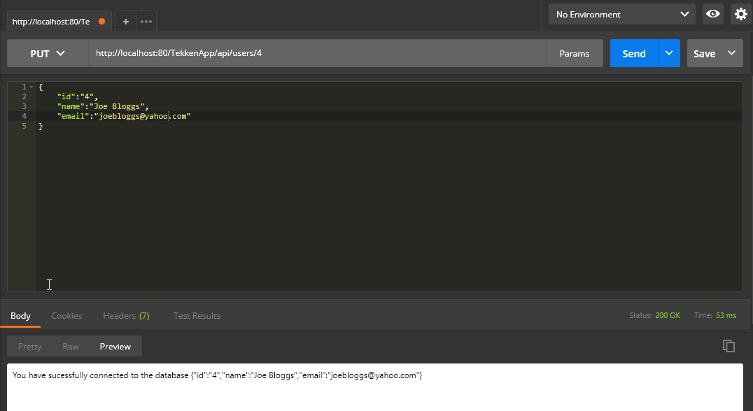

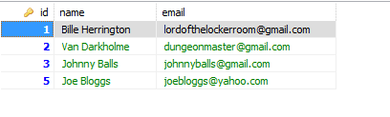

|  |  |
| --- | --- |
| User Story 5 | As an API Consumer, I want to update a user through JSON, so that I can use the data in my client application. |
| Test Case ID | 11 |
| Description | Incorrect parameters entered – Success |
| Given | 1. The Application Server and Database Server is running 2. Postman REST Client Opened |
| When | 1. Set GET request 2. Enter URL  <http://localhost:80/TekkenApp/api/users/>{invalid id} 3. Press send |
| Then | 1. Slim Application Error |
| Test Status | Passed |

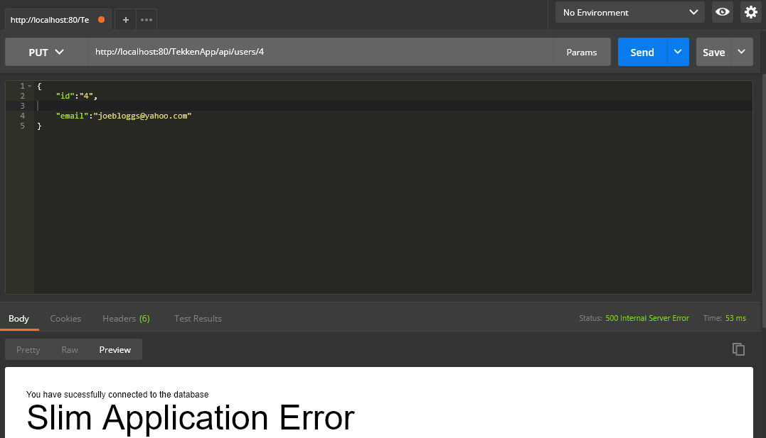

|  |  |
| --- | --- |
| User Story 6 | As an API Consumer, I want to delete a user through JSON, so that I can use the data in my client application. |
| Test Case ID | 12 |
| Description | The user was deleted – Success |
| Given | 1. The Application Server and Database Server is running 2. Postman REST Client Opened |
| When | 1. Set GET request 2. Enter URL  <http://localhost:80/TekkenApp/api/users/>{valid id} 3. Press send |
| Then | 1. HTTP Response 200 2. Row deleted from table |
| Test Status | Passed |

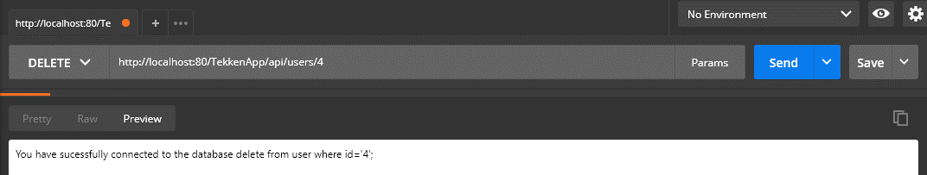

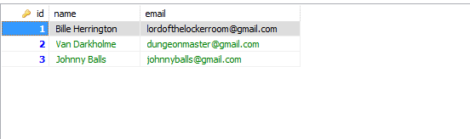

|  |  |
| --- | --- |
| User Story 6 | As an API Consumer, I want to delete a user through JSON, so that I can use the data in my client application. |
| Test Case ID | 13 |
| Description | Invalid ID entered – Success |
| Given | 1. The Application Server and Database Server is running 2. Postman REST Client Opened |
| When | 1. Set GET request 2. Enter URL  [http://localhost:80/TekkenApp/api/fighters/](http://localhost:80/TekkenApp/api/fighters/search/%7binvalid_name%7d){invalid id} 3. Press send |
| Then | 1. HTTP Response 200 2. Row not deleted from table |
| Test Status | Passed |

